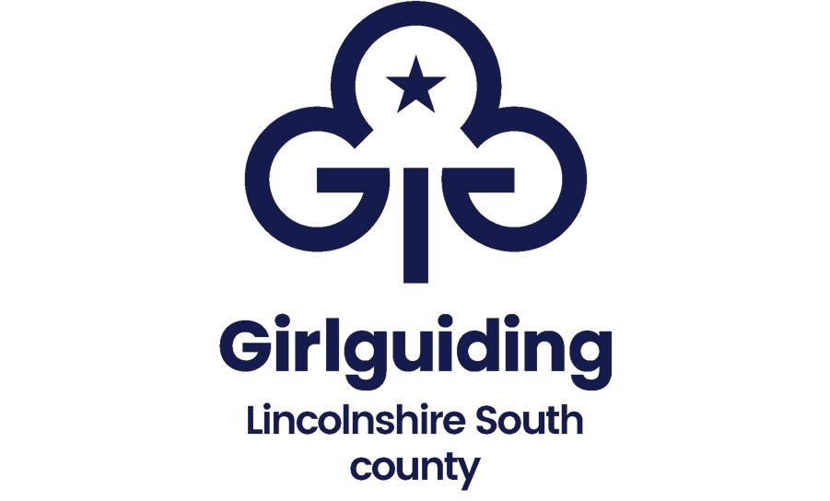

Consent form information sheet

When you share your story, photo or video with us you help us to shout about how great Girlguiding Lincolnshire South is, encouraging more girls to join and more people to get involved.
But before we can use it, we need your consent. You can give us that by filling in this consent form.
On it, you can tell us more about:
- How you’d like your story, photo or video to be used
- How you’d like us to contact you if we need to check information
Where might we use your content?
Girlguiding Lincolnshire South might use your story, photo or video in:
- Digital and printed communications - like emails to members and guiding magazine
- Social media and websites - like girlguidinglincolnshiresouth.org, Facebook, Twitter and Instagram
- Internal publicity - like photos on walls in Girlguiding buildings
- Marketing, advertising and press - like Girlguiding campaigns, fundraising and events and national or local TV or radio
- To support our work with Girlguiding partners or affiliates - for use on their communications
Sometimes we may need to tweak your story, photo or video such as making it shorter in a video edit, or just use a quote from an interview.

Occasionally when sharing your story, photo or video we may need to use your first name, role and/or unit name.

If you’re under 14, we’ll only use your first name, section and region. We’ll never use any other details without your permission.

We’ll keep your story, photo or video in a safe secure place for three years. After three years we’ll remove your content from our system.

If you have any questions or if you would like to remove or change your consent at any time, please contact pr@gglincssouth.org.

If you withdraw consent, we’ll stop using your story, photo or video in any future materials. Where your content has been used in the past, we’ll tell you where it’s been used and take practical steps to replace it. However, we can’t guarantee that your content is out of circulation due to the nature of digital and printed materials.

Look at our privacy notice for more information about how we’ll use and store your data.
www.girlguidinglincolnshiresouth.org/privacy-policy
Girlguiding Lincolnshire South image and photo consent form

This form is to be completed by the participant (if under the age of 14 this should be completed by a parent/guardian/carer)

Participant details:
Full name of participant: ☐ Under 14 (please tick if applicable)
Membership no: Section: Unit: Country or region:

Contact details (if under 14 this should be the details of the parent/guardian/carer)
Name (if parent/guardian/carer):

If we need to check any details about consent, how would you like us to contact you?
☐ Phone: ☐ Email:

Consent: (please tick the relevant boxes)

I / on behalf of the child named above, give Girlguiding Lincolnshire South permission to use my content for the following:
- Girlguiding Lincolnshire South digital and printed communications and publications
- Girlguiding Lincolnshire South social media and websites
- Girlguiding Lincolnshire South internal publicity
- Girlguiding Lincolnshire South marketing, advertising or press
- Girlguiding Lincolnshire South partners for their communications
- I understand the personal information I give above will be used by Girlguiding Lincolnshire South for recording consent only

Signature: Date:

If you’re completing this form electronically, add your name to the signature line above and attach it to an email. This will show you give consent.
If you have any questions or if you would like to remove or change your consent at any time, talk to your unit leader to make changes to your consent options, or contact pr@gglincssouth.org.

