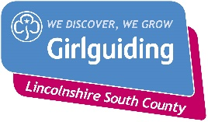

Lincolnshire South County
badge and standard order form
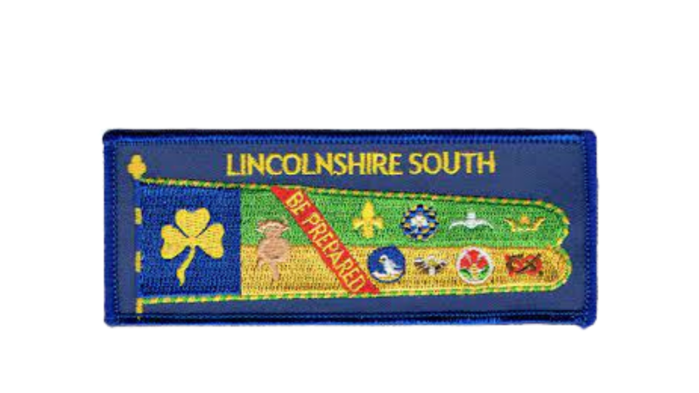

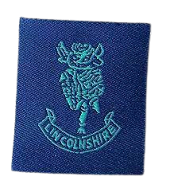
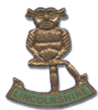

Metal County Badge
County Standard
Cloth County Badge

Badge | Price | Quantity
County standard woven badge | £1.00
County badge – Metal | £2.50
County badge – Cloth | £0.20

Postage and packing will be added to your invoice

Contact name and address (and unit if applicable):

Email (in case of query):

Send your order form via email to:
badgesecretary@gglincssouth.org

