

Leaders Guide to Community Safety Award “Home Award” 5-10 year olds.

Leaders Information;
This pack is designed to help 5-10 year olds gain the Community Safety Award. Activities can be undertaken either at home or in the Group.

How it works:
There are nine activities; the first two are compulsory and you must complete another four to gain the Community Safety Award

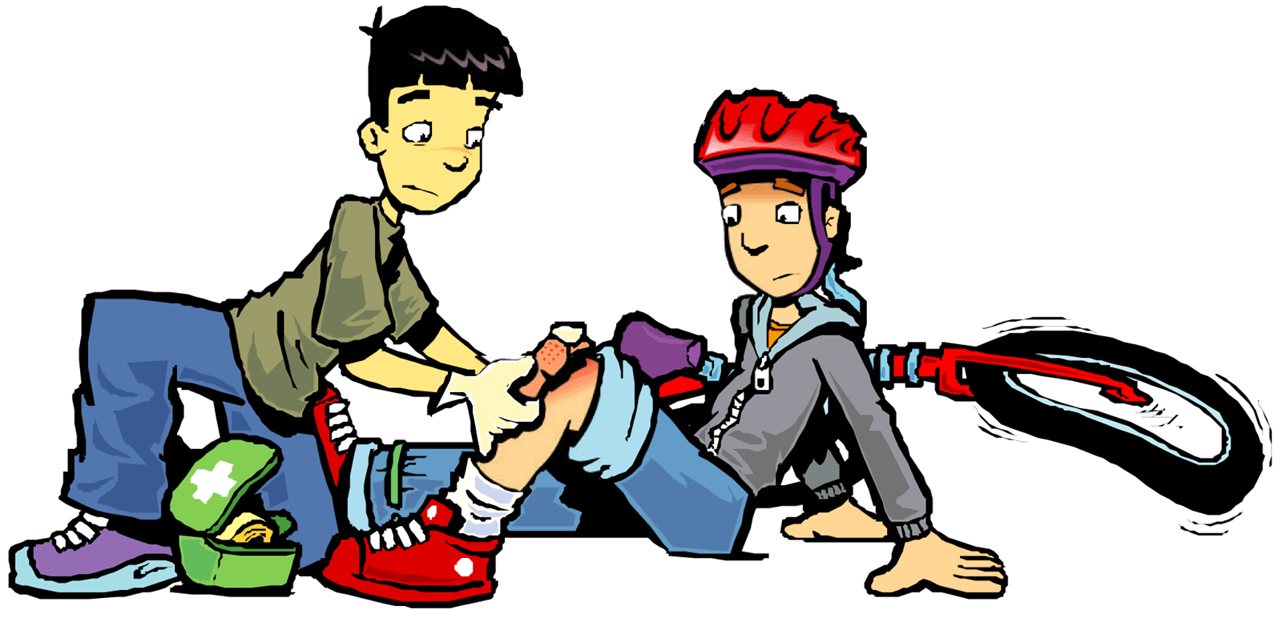

Gain the Community Safety Award

- Think what you might need in a household grab bag, do you have pets, what they would need.
- Draw a map of an escape route from your home/meeting place.
- If the danger is OUTSIDE, what would you do? If the danger was INSIDE, what would you do?
- Visit or find out about a Power station / fuel depot or flood defence scheme or any other place that is similar and has managed hazards.
- Find out if your house/meeting place lies within the flood plain, who would you need to contact, or how would you find this information, are there any other risks associated with where you live/meet.
- What would you consider to be an emergency?
- Who might be involved in an emergency; list the different agencies that might be involved depending on the incident.
- What would you need to do to make your home secure if you were being evacuated.
- Who near you, or in your community may need your assistance during an incident. Name 3 categories of people.

Leaders Guide

Think what you might need in a household grab bag, do you have pets, what they would need.

- Details of regular prescriptions items for your family
Could the youngsters put a bag together for the centre / their home? Or create a picture style activity for them to choose what to put it- put in some non-required items too.
- Paper copy of useful telephone numbers
- Mobile phone and charger
- Important documents
- National Health Service Number
- Important computer information on a memory stick
- Toiletries
- First aid kit
- Antibacterial hand gel
- Bottles of water
- Snack bars / chocolate
- Wind up or battery radio including spare batteries
- Wind up torch or torch with spare batteries
- Notebook and pen / pencil
- Essential keys (House)
- Special items (Glasses / contact lenses etc)
- Cash
- Baby food / milk / nappies etc
- Other items you may need – make a list (playing cards, toy puzzle etc)

Pets (keep a separate emergency bag for your pets in case they need to be evacuated. Contents will depend on the type of pet but may include):

- Water, food and bowls
- Leash / muzzle / harness
- Medication, health records, licence and microchip numbers
Google maps and draw line on the map?
- Blanket, pet carrier or cage
- Photo of your pet in case it gets lost
- Plastic bag for waste

Draw a map of an escape route from your home/meeting place.

- How would you get out of your house should there be flooding etc, where is there a communal safe meeting place, where to meet if you get separated.

If the danger is OUTSIDE, what would you do? If the danger was INSIDE, what would you do?

- Remember the saying; if the danger is OUTSIDE; Get in, Stay in and Tune in (to local radio, news, websites, social media)
- Remember the saying, if the danger is INSIDE; Get out, Stay out and dial 999

Visit or find out about a Power station / fuel depot or flood defence scheme or any other place that is similar and has managed hazards.

- Examples Military base, police and fire initiatives, prisons, or police cells, sheltered accommodation, coast guard, docks. Contact details can be found in the phone book.

Find out if your house/meeting place lies within the flood plain, who would you need to contact, or how would you find this information, are there any other risks associated with where you live/meet.

http://www.environment-agency.gov.uk/homeandleisure/floods/default.aspx
- If your home/meeting place does lie within a flood plain, have you signed up to flood warning direct?
- Do you live/meet near pylons, telephone masts, rivers etc

What would you consider to be an emergency?
(Emergencies that could affect your family or home include):

- Weather related. (Flooding, storms, snow, heatwave)
- Industrial. (Loss of power, heating or water, chemical or nuclear leak)
- Disease (Pandemic flu or animal disease)
- Major transport accident (road, rail air, sea)
- Public safety (fire or terrorism)
- Coastal pollution (oil or other cargo washing ashore)

Who might be involved in an emergency; list the different agencies that might be involved depending on the incident.

- Fire– fire brigade
- RTC- Police, fire, ambulance
- Missing person – Police
- Injured person – Ambulance Service
- Flooding – Fire brigade, Environment Agency, Local Authority, Police etc
- Coastal Pollution – Marine and Coast Guard Agency, Environment Agency Local Authority, Police

What would you need to do to make your home secure if you were being evacuated.

- Fetch your grab bag, switch everything off and lock your home, doors and windows. If you were making your own arrangements instead of going to a centre nominated by the Local Authority or emergency service, notify some one to let them know you are safe. Depending on the incident you may be asked to make your way to a local centre or collection point if possible. If not you need to contact the authorities on the number which will be provided and await assistance.

Who near you, or in your community may need your assistance during an incident. Name 3 categories of people.

- Old and infirm
- Pregnant ladies
- Vulnerable adults and children
- Neighbours who may have recently broken a limb or had an operation
- Those less able to help themselves
Term vulnerable may need explaining- all of the listed could be classed as vulnerable

Further useful information to help with the Award can be found on:

http://www.lincolnshire.gov.uk/lincolnshire-prepared/

Try this game if you have access to the internet:
http://www.crucial-crew.org/what-if/
What if? Interactive game.

