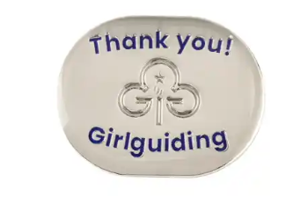
For adults (leaders, unit helpers and supporters) who have made a positive contribution to Girlguiding Essex South East over a period of time or for a special project/area.
Girlguiding Thanks Badge
AWARD NOMINATION FORM

Nominees Full Name:
Membership Number:
Current Guiding Appointment(s):
Reason for Nomination:

Name of Proposer:  BLOCK CAPITALS PLEASE | Name of Seconder:  BLOCK CAPITALS PLEASE
Signature of Proposer:  CAN BE ELECTRONIC | Signature of Seconder:  CAN BE ELECTRONIC
Date:

Please return this form via email to: county.commissioner@girlguidingessexsoutheast.org.uk

