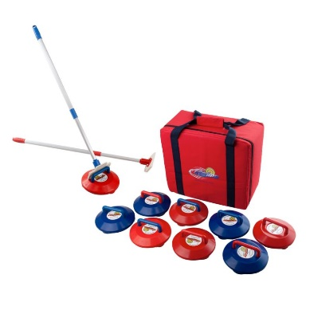
INDOOR CURLING EQUIPMENT
Guideacres now owns a set of indoor Curling Equipment for the use of hirers of Guideacres. It is kept at Guideacres (in the outside store room)
It is suitable for use by all ages [Rainbows to Trefoil Guild] and all abilities [able bodied to wheel chair users]
The equipment can also be hired for use away from Guideacres, at £10 a session, when Guideacres not booked .
To hire this equipment please complete form below and return to:
Judy Turner [ bookings@guideacres.org.uk ]

Conditions of hire
- Hirer to collect equipment [curling stones, target, pushers] from the outdoor store at Guideacres prior to use. Ensure you have the current gate code and keysafe code.
- Hirer to return equipment to Guideacres as soon as possible after use (liaise with booking secretary as to appropriate day) .
- When equipment back in storeroom please take a photo and send to booking secretary
- Payment of £10 preferably by transfer to:
Girlguiding Guideacres, Sort code 20-49-29, Account no 80845361. [Ref – curling]
Or a cheque payable to Guideacres

…………………………………………………………………………………………………………………………………………………….
INDOOR CURLING EQUIPMENT HIRE
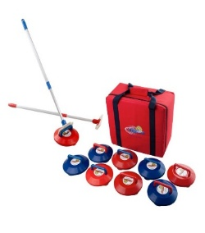
Unit
Contact name
Email address Phone number
Date required
[I agree to the conditions of hire]

