 | 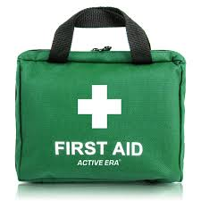  First Response Training

MODULE 1 – FACE TO FACE SESSION

TUESDAY 18TH AUGUST 2026

ST. MARY’S ROOMS, CHURCH ENDS, GREAT DUNMOW. CM6 2AD
(Parking in car park behind St. Mary’s Church)

7.15 p.m. – 9.30 p.m.

Please note that all Modules are required to gain the qualification. You must also complete the e-learning module on-line. This may be done before or after the other sessions, but the qualification cannot be entered on GO until it is completed.

Please complete the attached form and email to County Office before 8th August 2026 to book your place.

Remember that the 2-hour renewal option is no longer available.

------------------------&-----------------------------------------------------------------------------------------------------------

First Response Training 18th August 2026

Name …………………………………………… Division ………………………………………

Membership Number ………………………

Unit ………………………………………………………. Rainbows/Brownies/Guides/Rangers

Telephone………………………… Email ……………………………………………………………………

Reply to: - Girlguiding Essex West – office@girlguidingessexwest.org.uk

