 | 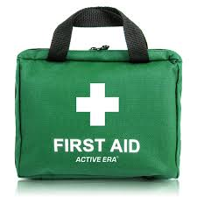  Safer Guiding &  First Response Training

The Trainers are offering the following sessions for Safer Guiding and Module 1 – face to face for First Response on:-
Saturday 9th May 2026 at
The Pines, The Avenue, Brentwood, Essex. CM13 2AD.

Refreshments will be provided, but please bring your own cup/mug. If staying for both sessions, you will need a packed lunch.

SESSION | TIME | ATTEND
Safer Guiding | 10.00 a.m. – 1.00 p.m.
First Response Module 1 | 1.30 – 3.30 p.m.

Please indicate which sessions you wish to attend

Please complete the form below and email to County Office to book your place. Places will be limited, so booked on first come, first served basis.

Name …………………………………………… Division ………………………………………

Membership Number ………………………

Unit ………………………………………………………. Rainbows/Brownies/Guides/Rangers

Telephone………………………… Email ……………………………………………………………………

Reply to: - Girlguiding Essex West – office@girlguidingessexwest.org.uk

