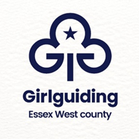

International Opportunities Event

When: Sunday 5 July 2026, 10am to 4pm

Where: Skreens, Park Roxwell, Chelmsford

Who’s it for? - Guides, Rangers and Young Leaders who will be 14-18 at the time of travel. Trips will be taking place in the summer holidays 2027 and 2028.

What’s it about? - This event is to explore international opportunities open to you through Girlguiding. Currently planned in 2028 is Italy and Our Chalet in Switzerland. Plans for 2027 are still being considered and 2028 could change.

You will be taking part in team building activities whilst making new friends.

The event will be run by County Advisors, who will select 4/5 girls to go forward to the Region International Opportunities event which will be on 3 October in Ely.

What’s expected? - Enthusiasm for Guiding and a desire to travel.

How much does it cost? - £10

What do I need to do now? - To book a place email Fiona Fraser (internationalessexwestguides@gmail.com). Application form will be sent for completion and return by 31 May 2026.

A consent form will be sent together with details for the day and how to pay will follow nearer the date.

