

A traditional trip
around the British Isles

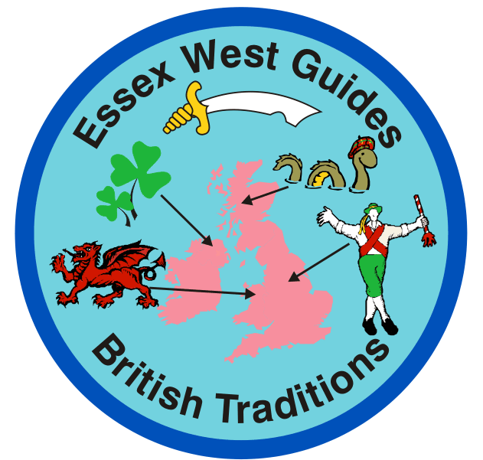

Contents

Town crier | Page | 3 | Drama
Advert for the British Isles | Page | 4 | Drama
Rhyming Slang | Page | 4 | Drama
Punch and Judy | Page | 4 | Drama
How to make a punch and Judy Show | Page | 5 | Drama
The Kilt Challenge | Page | 6 | Drama
What’s the time Mr Wolf | Page | 7 | Traditional playground games
Apples, peaches, pears and plums | Page | 7 | Traditional playground games
Teddy bear Teddy Bear | Page | 7 | Traditional playground games
Oranges and Lemons | Page | 8 | Traditional playground games
The big ship sails on the alley alley oh | Page | 8 | Traditional playground games
One little elephant went out to play | Page | 9 | Traditional playground games
A Sailor Went To Sea | Page | 9 | Traditional playground games
Nuts in May (rhyme) | Page | 10 | Traditional playground games
Brecon Light Cakes | Page | 12 | Food
Leek and Cheese Flan | Page | 12 | Food
Leek and Potato Soup | Page | 13 | Food
Salmon Fish Cakes | Page | 13 | Food
Teisen Lap | Page | 14 | Food
Treacle Scones | Page | 14 | Food
Welsh Cakes | Page | 15 | Food
Apple Scone | Page | 15 | Food
Arran Potato Salad | Page | 15 | Food
Cheese Scones | Page | 16 | Food
Crispie Mars Bars | Page | 16 | Food
Finnan Haddie | Page | 17 | Food
Oatmeal Gingerbread | Page | 17 | Food
Toffee Apples | Page | 18 | Food
Cornish Pasties | Page | 19 | Food
Treacle Toffee | Page | 19 | Food
St Patrick Day Cookies | Page | 20 | Food
Weaving on card | Page | 21 | Craft
Paper weaving | Page | 21 | Craft
Weaving on a fork | Page | 22 | Craft
Lamb Brooch | Page | 22 | Craft
Patchwork poster | Page | 23 | Craft
Finger knitting | Page | 23 | Craft
Marbling on Paper | Page | 24 | Craft
Flags on safety pins | Page | 26 | Craft
Match the cards | Page | 28 | Quiz
British isles (Running game) | Page | 29 | Quiz
Doing the Lambeth Walk. | Page | 30 | Songs
My Old Man Said Follow The Van | Page | 30 | Songs
Bless 'em all | Page | 31 | Songs
Land of Hope and Glory | Page | 31 | Songs
You'll Never Walk Alone | Page | 31 | Songs
Oh I do like to be beside the seaside | Page | 31 | Songs
White Cliffs Of Dover | Page | 32 | Songs
We'll Meet Again | Page | 33 | Songs
Okey Kokey | Page | 33 | Songs
The National Anthem | Page | 34 | Songs
Word search | Page | 35 | Fillers
Tongue twisters | Page | 35 | Fillers
Four Corner game | Page | 35 | Fillers
Pearly Kings and Queens | Page | 36 | Fillers
Appendix A Slang | Page | 38
Certificate | Page | 41

----

I would like to say thank-you to all who contributed to this document, and to you for purchasing a copy. I hope you will find it useful and your girls enjoy taking part. I have tried to include something for all age groups. Topics include Drama, Craft, Food, Traditional games and some Old songs. You, the leader decides how much to complete before awarding the badge. A certificate is included for those wishing to copy and distribute.

Town Crier

Before the day of the Internet, radio or newspapers it was the town crier who brought news to the ordinary people.

Suggestion – open your meeting with a leader taking the role of town crier. Use text provided or adjust to suit your group. You may want to use a scroll of paper, and bell as used back then.

Town Crier
Oyez! Oyez! Oyez!

Be it known that in the year of our lord two hundred and seventy, the birth of St George did take place in the country now known as Turkey. He was a Christian who at the age of seventeen joined the Roman army and soon became renowned for his bravery. It was while St George was in England that he heard that the Emperor of Rome was putting all Christians to death, so he returned to Rome to help his brother Christians. St George pleaded with the Emperor to spare their lives and refused to give up his faith. And so it came to pass that on the twenty third of April in the year of our lord three hundred and three, St George was finally beheaded.

Be it further known that in the year of our lord one thousand two hundred and twenty two, the council of Oxford declared April twenty third to be St George’s day and in the fourteenth century, he became the patron saint of England.

Now Girlguiding Essex West has invited you all here today to share in some British traditions.

God bless you all, God Save The King.

Drama

Advert for the British Isles
Divide girls into groups. Each group has to make up an advert for the British Isles. You may want to set a time limit on the performance. When complete, the groups perform their sketch for unit.

---

Rhyming Slang (Appendix A)
Divide girls into groups. Give each group a different phrase, which they must include in a sketch.
The groups perform their sketch for the unit. Can the audience identify the phrase and its meaning?

Depending on the response of the girls, you may want to increase the number of phrases given. This should challenge the performer’s ability to script them into the sketch and the audience in remembering each one heard.

---

Punch and Judy
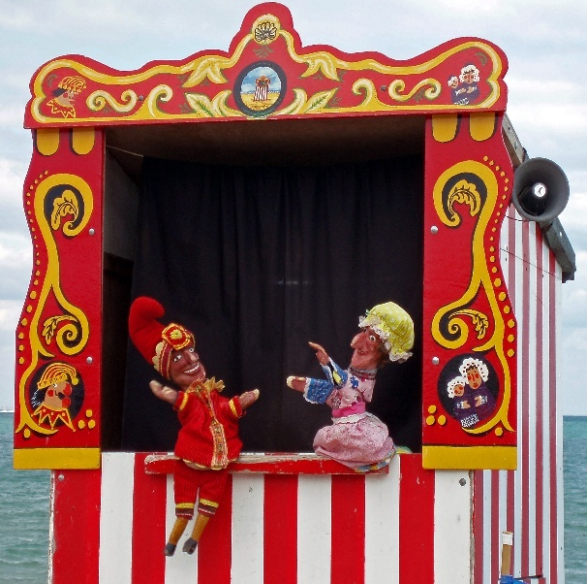
Punch and Judy is a popular puppet show featuring Punch and his wife Judy. The performance consists of a sequence of short scenes, each depicting an interaction between two characters. Punch wears a jester's motley, is hunchbacked and his hooked nose almost meets his curved jutting chin. He carries a stick, as large as himself, which he freely uses upon all the other characters in the show. He speaks in a bizarre rasping voice,

Do the girls have puppets at home they could bring to a meeting? Or can they improvise (e.g. socks can make basic puppets). In groups can they put on a short act to show to the group?

The more adventurous may want to make puppets.

How to make a punch and Judy Show
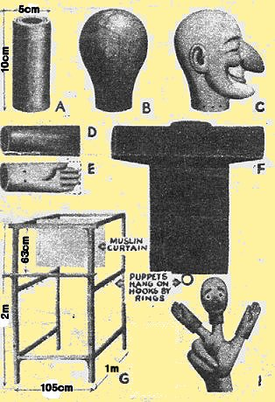
Materials required: Thick sugar-paper from a craft shop is ideal, or some newspapers), cold water paste, cardboard, poster, acrylic or oil paints, mixture of whitening and glue.
Head: Roll a strong tube of cardboard – 14cm long for Punch, 10cm long for other characters. Cover this with layers of paper, which have been torn (not cut) into small pieces and soaked in cold water paste (surplus paste should be squeezed out). When you have formed a rough head (B) insert a peg of wood in the position of the nose: this can be built up into the required shape for each character by using more paper. When the head has reached stage C, dry it slowly in the oven: a mixture of glue and whitening will give the head a smooth finish. Hair and whiskers can be made from crepe paper, odd bits of fur and wool. Paint the heads with bright colours, using poster, acrylic or oil paint.
Hands: Make two tubes of cardboard large enough to fit your thumb (D). Press one end of each tube flat and mark out the shape of the hand; cut away the unwanted parts (E). Cover the whole of the tubes with a layer of paper until a strong pair of bands is formed, then dry and paint them.
Body: Make a shirt of any strong cloth; fix the head and hands in position with thread sewn through holes pierced in the neck and wrists. The puppet can then be dressed in character and worked by inserting your index finger in the head and thumb and second finger in the arms. Fig. 1. Shows you how.
Stage and Fit-up: The Fit-up is made of three sections shown in G. The measurements shown are for a full size fit-up for an adult. The height will vary considerably depending on how tall you are. The shelf or stage should be about level with your wrists when you hold your hands in front of your face. The material is any wood about 4cm thick (clothes props will do), a shelf 1m 7cm long and 9 cm wide and 12mm thick is required for the stage. The corners of the frames should be fitted with 15cm angle brackets, and two are used to support the shelf. The three sections are bolted or tied together, and covered with cheap curtain lining or coloured hessian, The pelmet and curtains shown here are made from hessian and are hung from the top rail of the stage.
A curtain of muslin, 69cm deep and the width of the inside of box are hung on a rail about 30cm behind the stage opening. You stand behind this and because the box is covered in, you can see through the muslin, but the audience cannot see you. For this to work properly most of the available light should be from the front, and the curtains covering the fit-up should be as lightproof as possible.
Of course a fit-up is not absolutely necessary. You can do a very entertaining show from behind a clotheshorse draped with blankets.

---

The Kilt Challenge
Divide girls into teams. Give each team Newspaper, sellotape, pencil and ruler.
Task – working together as a team make a kilt, which will be modelled by one member of the team. (Set a time limit)
Put on a catwalk with a girl from each team describing their creation.

Traditional playground games

Chasing
What’s the time Mr Wolf?
One player is the wolf and she will stand with her back turned to the others about 5 meters from the others. The others call out "What’s the time Mr. Wolf?” and the wolf turns to face the others and shouts out a time. E.g. 10 o'clock. The others would then take 10 steps toward the wolf. The group will take the same amount of steps toward the wolf as the amount of hours in the wolf’s time. E.g. 2 o'clock = 2 steps, 6 o'clock = 6 steps etc. etc. The wolf will then turn his back to the group again for them to yell, "What’s the time?" (He looks at the group only when he shouts the time at the group". When the group gets close to the wolf the next time the group yells "what’s the time Mr. Wolf?" the wolf will say 'DINNER TIME" and run after the group who are running back to the start line, and hopefully catch one of the group who will then be the wolf. It sounds messy, but when played is an enjoyable game.

---

Skipping
Apples, peaches, pears and plums
Tell me when your birthday comes,
You would then skip really fast and say the months of the year (Jan, Feb, Mar etc) trying to not get out until you reached the month of your birthday.

---

Teddy bear Teddy Bear
The children jump rope while they sing this rhyme, they act out the actions as the words come up in the rhyme. An example: when they say go upstairs, the child pretends to climb the stairs.

Teddy Bear, Teddy Bear, turn around,
Teddy Bear, Teddy Bear, touch the ground
Teddy Bear, Teddy Bear, show your shoe
Teddy Bear, Teddy Bear, that will do!
Teddy Bear, Teddy Bear, go upstairs-
Teddy Bear, Teddy Bear, say your prayers-
Teddy Bear, Teddy Bear, turn out the lights-
Teddy Bear, Teddy Bear, say goodnight!

Chains and captives
Oranges and Lemons
Instructions –
Players file, in pairs, through an arch made by two of the players (made by having the players face each other, raise their arms over their head, and clasp their partners' hands).

On the last word, ‘Dead.’ the children forming the arch drop their arms to catch the pair of children currently passing through, who are then "out" and must form another arch next to the existing one. In this way, the series of arches becomes a steadily lengthening tunnel through which each set of two players have to run faster and faster to escape in time.

The game works best with a pianist to play the tune, so that unpredictable changes of tempo can be introduced.

Oranges and lemons say the Bells of St. Clement’s
You owe me five farthings say the Bells of St. Martin's
When will you pay me? say the Bells of Old Bailey
When I grow rich say the Bells of Shoreditch
When will that be? say the Bells of Stepney
I do not know say the Great Bells of Bow
Here comes a Candle to light you to Bed
Here comes a Chopper to Chop off your Head
Chip chop chip chop - the Last Man's Dead.
-----

The big ship sails on the alley alley oh,
Instructions -
1st girl places hand against the wall, other end passes through arch between wall and 1st girl, when all girls have passed through the 1st girl finds her arm being pulled under her so that her body is twisted round to face the other way, her arms are crossed. The leader of the line then circles round and passes through the arch between the 1st girl and her neighbour; continue singing the first verse until the last girl has her arms crossed.

The two ends join up to make a circle, the second verse is sung, and the heads are lowered to emphasize the words. The players then let go and wag forefingers at each other while singing the third verse.

The big ship sails on the alley alley oh
The big ship sails on the alley alley oh
The alley alley oh, the alley alley oh
The big ship sails on the alley alley oh
On the last day of September.

The captain said it will never never do
Never never do, never never do.
The captain said it will never never do
On the last day of September.

The big ship sank to the bottom of the sea
The bottom of the sea, the bottom of the sea.
The big ship sank to the bottom of the sea

On the last day of September.
-----

Static circles
One little elephant went out to play

Instructions
Form a circle. One player is chosen. She tramps around the outside. Holding her nose with one hand and puts the other hand hanging through the looped arm. When the first verse has been sung she nudges whoever is nearest to her, and that player joins her, holding her nose with one hand and putting the other hand hanging through the looped arm and holds on to the first.
This continues until everyone has been selected.

One little elephant went out to play
Out on a spider's web one day.
She had such enormous fun,
She asked another elephant to come.

Two little elephants……
-----
Handclapping game.
A Sailor Went To Sea
Instructions
In pairs, facing your partner
clap own hands together,
right hand with partner’s right hand,
own hands together
left hand with partner,
own hands together.

Then first verse “see see see” – Right hand above right eye (3 times).
repeat above till end of verse.

Second verse “chop chop chop” - Right hand chopping action (3 times).
Third verse “knee-knee-knee” - Pat right knee with right hand (3 times).
Fourth verse “sea-chop-knee “ Right hand above right eye, chopping action, pat right knee with right hand

A sailor went to sea, sea, sea.
To see what he could see, see, see.
But all that he could see, see,see.
Was the bottom of the deep blue sea, sea, sea.

A sailor went to chop-chop-chop,
to see what he could chop-chop-chop,
and all that he could chop-chop-chop
Was the bottom of the deep blue chop-chop-chop.

A sailor went to knee-knee-knee,
to see what he could knee-knee-knee,
and all that he could knee-knee-knee
Was the bottom of the deep blue knee-knee-knee.

A sailor went to sea-chop-knee
to see what he could sea-chop-knee
and all that he could see-chop-knee.
Was the bottom of the deep blue see-chop-knee

-----

Contest
Nuts in May (rhyme)

Aim of the game is to become the largest team by winning members from the opposing teams.

Instructions

Divide girls into two teams (Team A and Team B)

Select a captain for each team.

Teams stand in a line facing each other, leaving a fair sized gap.

1st Round

Team A chooses a girl from each team. Their names are inserted into verses 3 and 5. Verse 3 name of girl from Team ‘B’. Verse 5 name of girl from Team ‘A’.

Once all 5 verse have been sung, the two captains walk to the middle of the gap between the teams and form a line on the floor with their right feet.

The two chosen girls join them, and stand facing each other in front of the line

On the word ‘go’ they pull the opponent until one crosses the line.

The loser (the one that crossed the line) joins the winner’s team.

2nd Round Team B turn to choose and sing verse 1 etc.
Game continues until one team has no one left.

Note: The team choosing the names cannot send the same girl from their own team twice.

Verse 1
(1st Round sung by Team ‘A’ while walk or skip forward towards Team ‘B’ and back again)
Here we go gathering nuts in May,
Nuts in May, nuts in May,
Here we go gathering nuts in May
On a cold and frosty morning.

Verse 2
(1st Round sung by team ‘B’ while walk or skip forward towards Team ‘A’ and back again)

Who will you have for nuts in May,
Nuts in May, nuts in May,
Who will you have for nuts in May,
On a cold and frosty morning.

Verse 3
(1st Round sung by team ‘A’ while walk or skip forward towards Team ‘B’ and back again)

We’ll have name for nuts in May,
Nuts in May, nuts in May,
We’ll have name for nuts in May,
On a cold and frosty morning.

Verse 4
(1st Round sung by team ‘B’ while walk or skip forward towards Team ‘A’ and back again)
Who will you have to fetch her away,
Fetch her away, fetch her away,
Who will you have to fetch her away
On a cold and frosty morning.

Verse 5
(1st Round sung by team ‘A’ while walk or skip forward towards Team ‘B’ and back again)
We’ll have name to fetch her away,
Fetch her away, fetch her away,
We’ll have name to fetch her away,

On a cold and frosty morning.

---

Food

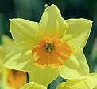
Brecon Light Cakes
Ingredients
4 oz self-raising flour
½ teaspoon salt
2 oz caster sugar
2 eggs
2 tablespoons orange juice
2-3 tablespoons milk
1 oz margarine for frying
1 oz soft brown sugar

Method
Beat the eggs together with half the orange juice. Sift the flour and the salt into a mixing bowl and add the caster sugar. Add the egg mixture, stirring well. Beat in milk to produce a fairly thin batter. Melt the margarine in a heavy frying pan. When it begins to sizzle, drop in tablespoons of the mixture, allowing room to spread (2 – 3 inches). Cook on each side until golden brown. Drain on kitchen paper. Serve sprinkled with brown sugar and orange juice.
---

Leek and Cheese Flan
Ingredients
10 oz shortcrust pastry
2 large leeks
Oil or butter to saute the leeks
3 large eggs
3 fl oz milk
3 fl oz soured cream
A pinch of salt
6 oz cheddar cheese
Ground nutmeg

Method
Set oven to 400F or Mark6. Line a 9 inch flan tin with the pastry. Slice the washed leeks and saute them in a pan until they are just soft; season with black pepper and cool. Whisk together the eggs, milk, soured cream and a pinch of salt and then add half the cheese and the leeks to this mixture. Pour into the flan case and sprinkle the remainder of the cheese over the top. Grate some nutmeg over, place on a pre-heated baking sheet in the oven and bake for ½ an hour until golden brown

---
Leek and Potato Soup
Here’s a simple recipe for a tasty, hearty soup.
Ingredients:
Six potatoes, diced
3 leeks, chopped
1¼ pints (750ml or 3 cups) chicken stock
Salt and freshly ground black pepper to taste
1 ounce (25g or ¼ stick) butter or margarine
2 ounces (50g or half cup) grated cheddar cheese

Method:
Boil the potatoes and leeks in water for about 15 minutes until the potatoes start to disintegrate. Season to taste with salt and pepper. Work in the butter or margarine and serve with a sprinkling of grated cheese.
---
Salmon Fish Cakes
Ingredients
8 oz poached salmon, finely flaked
1 lb potatoes, peeled
3 oz butter
1 tablespoon parsley
1 tablespoon chives
Salt and pepper
Zest of ½ lemon
Oil for frying

Method
Boil the potatoes until tender. Mash well with 1 oz of butter and mix in the finely- flaked salmon, the chopped parsley, chopped chives and lemon zest. Season to taste with salt and pepper. Turn out on to a floured surface, divide into 8 portions and shape into cakes. Fry in 2 oz of butter mixed with oil until golden brown on each side. Drain on kitchen paper. Serve as a starter on a bed of lettuce with soured cream and chive dressing or as a main course garnished with parsley and lemon wedges.
---
Teisen Lap
Ingredients
½ lb plain flour
1 pinch salt
1 teaspoon baking powder
1 pinch nutmeg
4 oz butter
2 oz caster sugar
4 oz currants
2 eggs well beaten
¼ pint milk

Method
Set oven to 350F or Mark4. Grease a shallow baking tin. Sieve the flour, salt, baking powder and nutmeg into a bowl. Rub in the butter and mix in the sugar and the currants. Beat the eggs well and mix into the dry ingredients. Add the milk slowly and beat well to make soft dough. Pour the mixture into the tin and bake for 30 – 40 minutes until light golden brown.

---
Treacle Scones
Ingredients
12 oz self raising wholemeal flour
3 oz butter
1 dessertspoon black treacle
½ teaspoon salt
1 oz milk (approx)

Method
Set oven to 400F or Mark6. Add in the salt to the flour in a mixing bowl and rub in the butter until the mixture resembles breadcrumbs. Stir in the treacle and enough milk to make soft dough. Roll out gently on a floured surface to about 1 – 1¼ inches in thickness and cut into rounds with a 2 inch pastry cutter. Place on a greased and floured baking tray and bake at the top of the oven for 10 – 15 minutes. Cool on a wire tray. Serve the scones cut in half and buttered; they are delicious with lemon cheese.

---

Welsh Cakes ~ Pice ar y maen
Ingredients
1lb flour
1 teaspoon baking powder
1 pinch mixed spice
1 pinch salt
4 oz butter
4 oz lard
7 oz sugar
4 oz seedless raisins
2 eggs, beaten
Milk to mix
Caster sugar to sprinkle

Method
Stir together the flour, baking powder, allspice and salt in a large bowl. Rub in the butter and lard. Add the sugar and raisins. Beat the eggs and add to the mixture, with a little milk, to make a fairly stiff dough. Roll out to a thickness of about ¼ inch and cut into 2 inch rounds with a pastry cutter. Cook on a greased griddle or heavy based frying pan for about 3 minutes each side until golden brown. Sprinkle with sugar and serve warm.

---

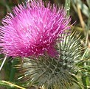
Apple Scone
There are many different varieties of scone – this one uses finely chopped apple to supply its flavour.

Main Ingredients:
One medium cooking apple
8 oz (250g) self-raising flour (all-purpose flour with baking powder)
½ teaspoon salt
Level teaspoon baking powder
2 oz (60g) butter
2 oz (60g) castor (fine granulated) sugar
Up to ¼ pint (150ml) milk

Ingredients for glaze:
A little milk
1oz Demerara (light brown) sugar

Method:
Pre-heat the oven to 200C (400F or Gas Mark 6).
Peel and core the apple and then finely chop. Sift together the flour, salt and baking powder. Then rub in the butter followed by the sugar and chopped apple and mix. Add milk until you have soft but not sticky dough.
Roll out on a floured surface to about ¼” thick and 8” round and mark into 8 wedges. Place on a greased baking sheet; brush the top with milk and sprinkle with the Demerara (light brown) sugar. Bake in the pre-heated oven at 200C (400F or Gas Mark 6) for 20-25 minutes. Serve warm with butter.
---

Arran Potato Salad
Use a potato variety, which produces a firm, waxy texture when cooked.

Ingredients:
10 waxy potatoes, diced
4 ounces (100g) shelled fresh peas (or frozen peas)
4 ounces cooked beetroot (red beets) diced
Salt and freshly ground black pepper
Two teaspoons chopped onion
One teaspoon chopped fresh parsley
Four tablespoons (60ml) salad dressing or salad cream
Fresh parsley to garnish

Method:
Boil the potatoes in salted water for ten minutes or until tender. Drain and pat dry. Cook the peas separately for about five minutes or until tender and then drain.
While the vegetables are still warm, mix together and stir in the chopped parsley and onion and season with salt and pepper to taste.
Fold in the salad dressing (or salad cream) to moisten, and garnish with sprigs of fresh parsley.
Cheese Scones
This is a tasty variation on the standard scones which are served at tea time.

Ingredients:
6oz (180g) self-raising flour
1oz (30g ) butter
1 large egg
2 or 2½ tbsp milk
4oz (125g ) grated cheese (use whatever strength you prefer)
½ tsp salt
½ tsp mustard powder
Cayenne pepper to taste

Method:
Mix the flour, salt and pepper together. Rub in the butter and then mix in the cheese. Beat the egg and add in the milk; add mixture to the dry ingredients to make a soft, elastic dough. Roll out the mixture on a floured surface but not too thinly. Cut into round shapes and place on a well-greased tray. Brush the top with milk and sprinkle a little extra cheese and pepper on top.
Bake in a pre-heated oven on a high shelf at 220C/425F/Gas Mark 7 until golden brown. Serve warm with butter.
---
Crispie Mars Bars
The conventional way to melt chocolate is to put it in a bowl above a pan of warm water but the recipe below suggests using a microwave.

Ingredients:
Three 65g (large) Mars bars, chopped up
3 oz (90g) margarine
Three to four cups of rice crispies
8 oz (250g) chocolate
1 oz (30g) margarine

Method:
Combine the 3 ounces of margarine and the chopped Mars bar pieces in a microwaveable bowl and melt on a medium heat. Do not overheat. Stir in the rice crispies until they are well covered by the mixture. If the mixture becomes too hard when you stir in the rice crispies, put back in the microwave for a few seconds.
Line a 9” (23cm) square tin with greaseproof paper (vegetable parchment or waxed paper) and spread the mixture evenly into the tin.
Melt the one oz of margarine and all the chocolate in a microwaveable bowl on a medium heat and spread over the mixture in the tin. Do not overheat the chocolate. (But if you do add two or three drops of cooking oil and beat with a spoon until it has smoothed out again).
Allow the mixture and chocolate to cool and cut into squares.
---

Finnan Haddie
The quantities are sufficient for four people.

Ingredients:
One pound (500g) smoked haddock
One large onion, thinly sliced
14oz (400ml) milk
½ teaspoon cracked pepper
1½ teaspoons mustard powder
1oz (30g) butter, softened
2 teaspoons plain flour
1 finely chopped spring onion
Some finely chopped parsley

Method:
Place the thinly sliced onion in the base of a large pan. Cut the smoked haddock into pieces about ½” to an inch (2cm) wide and spread over the onion.
Mix the milk, pepper and mustard and pour over the fish. Bring to the boil slowly, reduce the heat to low and simmer covered for five minutes. Then uncover and simmer for another five minutes.
Remove the fish from the pan with a slotted spoon to allow the juices to run off and place in a warm serving dish. Continue to simmer the mixture in the pan for another five minutes, stirring frequently.
Mix the warm butter and flour and add to the pan along with the finely chopped spring onion. Stir over a low heat until the mixture comes to a slow boil and thickens slightly. Pour over the fish and serve with some finely chopped parsley.

Oatmeal Gingerbread
Here is a recipe, which uses one of the staples of traditional Scottish diet, oatmeal.

Ingredients:
6 ounces flour
2 ounces oatmeal
2 ounces soft brown sugar (light brown sugar)
2 ounces butter
2 tablespoons black treacle (molasses)
1 teaspoon of ground ginger
1 teaspoon mixed spices
1 large egg
1 level teaspoon bicarbonate of soda
3 tablespoons milk

Method:
Line a seven-inch square baking tin with greaseproof paper, which has been well buttered. Melt the butter, sugar and treacle in a saucepan over a gentle heat. Sieve the flour and bicarbonate of soda into a bowl. Add the oatmeal and spices. Add the melted butter and treacle mixture, a well-beaten egg and the milk to the bowl, stirring well until completely blended. Pour into the baking tin and bake in a pre-heated oven at 350F/190C/Gas Mark 4 for about 45 minutes. Allow the cake to cool for ten minutes before turning out onto a wire rack.

Toffee Apples
While the sugar, syrup and butter will certainly not help a politically correct calorie controlled diet. But at least the fruit is healthy!

Ingredients:
2 pounds (1 kilo or 5 cups) Demerara (light brown) sugar
Bit of butter
1 small teaspoon vinegar
1 dessertspoon golden syrup (or light corn syrup)
Half cup water
Sticks for holding the toffee apples (ice-lolly sticks do at a pinch)

Method:
Stir together the sugar, vinegar, syrup and water and heat until boiling, stirring continuously. Continue on a slow boil for 5/7 minutes, stirring occasionally. Insert the stick into the core of each apple and dip the apples into the mixture. Place on a greased tray, with the sticks in the air, until dry.

---

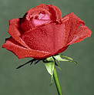
Cornish Pasties
Cornish pasties originated as portable lunches for tin miners, fishermen and farmers to take to work

Ingredients
Serves: 4
1 Medium Potato, cut into 5 mm ( ¼ inch) dice
1 Medium Onion, chopped
225 Gram Blade of beef or rump steak, cut into 1cm cubes (8 oz)
225 Gram Plain flour (8 oz)
50 Gram Butter, diced (2 oz)
50 Gram Lard, diced (2 oz)
Cold water, to mix
Beaten egg or milk, to glaze
Method
Pre-heat oven to 220 °C / 425 °F / Gas 7.
Place the potato, onion and meat in a basin and mix well. Place the flour in a bowl. Add the butter and lard, rub in until the mixture resembles fine breadcrumbs. Add about 2 tablespoons of water and mix to form firm dough. Turn out onto a floured surface and knead lightly.
Divide the pastry into 4. Roll out each piece to about 15-18 cm (6-7 inches). Trim by cutting round the edge of a small plate. Divide the filling between each round. Brush the edges with water and draw up the pastry on each pasty, in a line over the centre of the filling. Seal well. Flute the edge with your fingers.
Place the pasties on a baking sheet, fluted edges uppermost. Brush each with a little beaten egg or milk. Bake for 40-45 minutes, until golden brown. Serve hot or cold.
---

Treacle Toffee
Many areas of the north of England have their own recipes for toffee.

Ingredients
450 Gram Demerara sugar (1 lb)
150 ml Water ( ¼ pint)
75 Gram Butter (3 oz)
¼ Teaspoon Cream of tartar
110 Gram Black treacle (4 oz)
110 Gram Golden syrup (4 oz)
Method
Makes about 800g
Put the sugar and water in a large heavy-based saucepan, with a sugar thermometer attached, and heat gently until dissolved. Add the remaining ingredients and bring to the boil.
Boil until the temperature reaches the soft crack stage 132 °C (270 °F), when a little of the syrup dropped into cold water separates into hard but not brittle threads. Brush down the sides of the pan occasionally with a pastry brush dipped in cold water. Do not stir.
Pour into a greased 18 cm (7 inch) square tin. Cool for 5 minutes and mark into squares with an oiled knife when almost set. When set, break the toffee into squares and wrap in waxed papers or foil. Store in an airtight container.

---

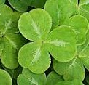
St Patrick Day Cookies
This is a basic and simple sugar cookie recipe. All you need is a round pastry cutter to make the leaves of the shamrocks.
Makes 12 cookies

Ingredients
2 ¼ cup self-rising flour
½ cup butter
1 cup sugar
2 eggs, beaten
1 tablespoon vanilla
1 tablespoon milk
Drops of green food colouring. Just enough to turn the mixture green!

Method
Sift flour. Cream butter, sugar, eggs. Add vanilla and milk to the flour. Blend all ingredients and then add the drops of green food colouring. Place dough on a lightly floured board or dry countertop.
Sprinkle some flour over the dough and roll to about ½-inch thick. Cut out 3 circles with the pastry cutter and overlap the circles into a shape of a shamrock and place on baking tray. Bake at 300 degrees for 10-15 minutes.

Craft

Weaving
All sorts of materials can be woven from twigs and grasses to string, wool, cloth and plastic. Get weaving and try some of the ideas below:

Weaving on card
You will need:
Card, wool, ribbons (or more wool), a large blunt needle or bodkin

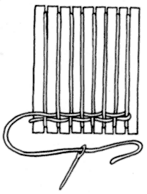
Cut notches in either end of some stiff card.

Wind wool around the card to form the ‘warp’.

Weave wool or ribbon in and out of the warp threads (the weft) to make your weaving.

-----

Paper weaving
You will need:
Coloured card, coloured papers

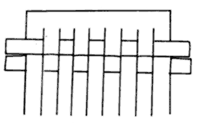
Cut vertical cuts in the coloured card, but not quite to the edge.

Weave strips of coloured paper through the card.

Stick loose ends with glue or Sellotape on the reverse of the weaving.

-----
Weaving on a fork
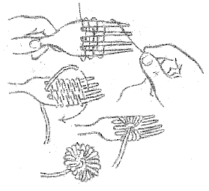
You will need:
Brightly coloured wool, felt, glue, darning needles and a card badge with a safety pin on the back and a fork.

Weave the wool in and out between the tines of the fork until there is no room (at least 8 rows)
Thread a piece of wool between the two middle tines, take it over the top of the weaving and tie it underneath, pulling tight.
Slide the weaving off the fork and fluff up the flower.
Trim off the loose ends of wool.
Make about 3 to 5 flowers, and then glue or sew them on to a length on to a length of felt to form a bookmark or glue them on to the card badge to make a posy pin.
-----
Lamb Brooch
(Fig A),
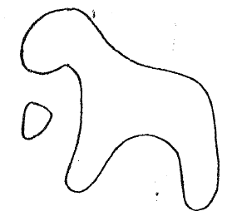
You will need:
Cardboard, black or beige felt, glue, scissors, 6 yards of white wool, a safety pin and one small eye.

Cut out cardboard lamb shape (Fig A), stick felt on to one side and trim round carefully.
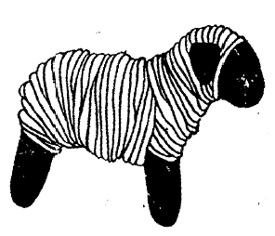
Stick felt on to the other side and trim as before. Start winding the wool from the centre of the body towards the head and then back again to the back leg until it is nice and fat. Fasten in the end of the wool and force a safety pin through the wool at the back. Stick on an felt ear and an eye.

Patchwork poster
You will need
Square paper or card, felt pens, paint or colouring pencils, Sellotape. Paper or card enough for a border.

Give each girl a piece of paper to decorate, you may wish to give the girls a theme such as flowers, hobbies or shapes. When they are finished combine these to form one panel, Sellotape the back. Add a border.

---

Finger knitting (No needles)

Finger knitting is a simple form of knitting in which a yarn of wool is knitted into a shorter but thicker twine. As its name suggests, the individual engaging in the knitting need only use their hands during the entire process.

How it’s done
Firstly the knitter should leave approximately three to four inches of twine before tying a slip knot. This knot should be wound around the knitter’s left thumb if they are right-handed or right thumb if they are left-handed. The loose end of wool should hang below the thumb with the wool positioned on their opposite side. Next a loop should be wound around the thumb below the nail and the first should be lifted over the new loop. Now the loose end should be tugged upon to tighten the knot on the thumb again. This process of looping and tightening should be repeated until the individual reaches the last three to four inches of twine, when the unused portion should be pushed through the thumb-knot to stop it from coming undone. At this point the knitter may wish to start again in order to form a twine thicker again.

Why it’s done
Finger knitting has been used to prepare to teach children how to knit traditionally with needles. It shows the child that knitting involves a series of loops strung together, which helps in their future understanding of knitting. Because of its simple execution it is ideal for this purpose as its concept can be grasped even by small children and continued without aid.

Marbling on Paper

You will need:
A large baking tray, at least 2.5cm deep
Water
Vinegar
(Wallpaper paste)
Oil based paints
White spirit to thin the paints if they are too thick

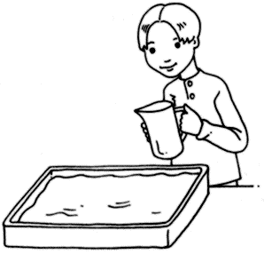
1. Fill the baking tray almost to the top with water.

Add a few drops of vinegar to the water. If you put wallpaper paste as well as vinegar into the water the pattern will be clearer and easier for young children to work with.

2. Sprinkle, place or drop paint onto the surface of the water using brushes, sticks or eyedroppers

Experiment with different procedures and see how it alters the pattern of the paint.

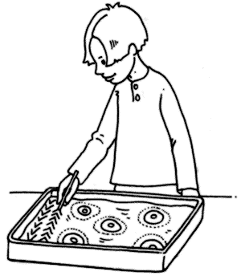
3. Move and swirl the paints with a stick or cardboard comb.

Experiment with different movements, such as swirls, zigzags or wavy lines.

4. Try painting a simple picture over the pattern.

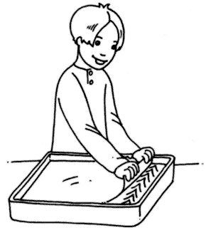

5. Lay a sheet of paper on the surface of the water.

Wait a few seconds.

Carefully lift it off.

6. Lay on newspaper or hang up to dry.

7. Try taking more than one print from the paints and observe the results.

Bead Flags on Safety Pins
You will need
Safety pins, white and red beads

Follow the chart, where you see W place a white bead onto the safety pin and where you see R place a red bead onto the safety pin.
When you have completed all 8 pins, use a safety pin to group them in the same sequence shown.

Each column represents a safety pin
Each row represents a bead | W | W | W | R | R | W | W | W
Each row represents a bead | W | W | W | R | R | W | W | W
Each row represents a bead | W | W | W | R | R | W | W | W
Each row represents a bead | R | R | R | R | R | R | R | R
Each row represents a bead | R | R | R | R | R | R | R | R
Each row represents a bead | W | W | W | R | R | W | W | W
Each row represents a bead | W | W | W | R | R | W | W | W
Each row represents a bead | W | W | W | R | R | W | W | W

You will need
Safety pins, White and blue beads

Follow the chart, where you see W place a white bead onto the safety pin and where you see B place a blue bead onto the safety pin.
When you have completed all 7 pins, use a safety pin to group them in the same sequence shown.

Each row represents a bead | Each column represents a safety pin
Each row represents a bead | W | B | B | B | B | B | W
Each row represents a bead | B | W | B | B | B | W | B
Each row represents a bead | B | B | W | B | W | B | B
Each row represents a bead | B | B | B | W | B | B | B
Each row represents a bead | B | B | B | W | B | B | B
Each row represents a bead | B | B | W | B | W | B | B
Each row represents a bead | B | W | B | B | B | W | B
Each row represents a bead | W | B | B | B | B | B | W

You will see I have used 2 white beads in the middle, you may want to
Skip one of these rows. I tried that but found the beads were to loose on the pins and did not hold the design in place. You may get a better result.
You will need
Safety pins, Green, white and orange beads

Follow the chart, where you see W place a white bead onto the safety pin and where you see G place a green bead onto the safety pin. Where you see O place an orange bead onto the safety pin.
When you have completed all 6 pins, use a safety pin to group them in the same sequence shown

Each row represents a bead | Each column represents a safety pin
Each row represents a bead | G | G | W | W | O | O
Each row represents a bead | G | G | W | W | O | O
Each row represents a bead | G | G | W | W | O | O
Each row represents a bead | G | G | W | W | O | O
Each row represents a bead | G | G | W | W | O | O
Each row represents a bead | G | G | W | W | O | O
Each row represents a bead | G | G | W | W | O | O
Each row represents a bead | G | G | W | W | O | O

Suggestion – use the chart for cross-stitch.

Quiz
You will need a copy for each group, cut out the boxes, give each group a set asking them to group the information.

England | Northern Ireland | Scotland | Wales
23rd April | 17th March. | 30th November | 1st March.
St. George | St. Patrick | St. Andrew | St. David
Rose | Shamrock | Thistle | Daffodil
London | Belfast | Edinburgh | Cardiff

Quiz (Running game)
For this multi choice quiz, give each of the 4 walls of your meeting place a letter A, B, C or D. Read out the question and the four answers. The girls’ run to the wall representing what they think is the correct answer. (These are underlined). You may want to award points for correct answers.

What is the Capital City of England?
a) Manchester | b) Birmingham | c) Loughton | d) London
What is the Capital City of Wales?
a) Caernarfon | b) Cardiff | c) Llandudno | d) Bangor
What is the Capital City of Scotland?
a) Aberdeen | b) Glasgow | c) Edinburgh | d) Dundee
What is the Longest river in England?
a) Lea | b) Severn | c) Thames | d) Ouse
What is the highest point in Wales?
a) Snowdon | b) Pembroke | c) Scafell Pike | d) Ben Nevis

Note Scafell Pike is the highest point in England while Ben Nevis is the highest point in Scotland.

Which is the busiest Airport in England?
a) Luton | b) Stanstead | c) City Airport | d) Heathrow
The national flower of Scotland is the?
a) Thistle | b) Lilly | c) Bluebell | d) Daisy
The national flower of England is the?
a) Shamrock | b) Daffodil | c) Buttercup | d) Rose
The patron saint of England is
a) St Edward | b) St. George | c) St Jake | d) St Gary
The patron saint of Wales is
a) St Dennis | b) St. David | c) St Judd | d) St Ann
The patron saint of Ireland is
a) St Paul | b) St Michael | c) St. Patrick | d) St Joseph
The patron saint of Scotland is
a) St. Andrew | b) St Ann | c) St Annabel | d) St Anthony
When do we celebrate St George’s Day?
a) 1st March | b) 23rd April | c) 17th March | d) 30th November

Sing song

Doing the Lambeth Walk.
Any time you're Lambeth way,
Any evening, any day,
You'll find us all
Doin' the Lambeth Walk.
Every little Lambeth gal,
With her little Lambeth pal,
You'll find 'em all
Doin' the Lambeth Walk.
Everything free and easy,
Do as you darn well pleasy,
Why don't you make your way there
Go there, stay there.
Once you get down Lambeth way
Ev'ry ev'ning, ev'ry day,
You'll find yourself
Doin' the Lambeth Walk.

------

Don't Dilly Dally (My Old Man Said Follow The Van)
(Charles Collins and Fred W. Leigh)
My old man said, "Follow the van, don't dilly dally on the way!"
Off went the cart with the home packed in it,
I walked behind with me old cock linnet.
But I dillied and dallied, dallied and dillied,
Lost the van and don't know where to roam.
You can't trust the specials like the old-time coppers
When you can't find your way home.
------

Bless 'em all
Words and music by Irving Berlin
Bless 'em all, bless 'em all
The long and the short and the tall
Bless all the sergeants and W.O. Ones
Bless all the corp'rals and their blinking sons
For we're saying good-bye to them all
As back to the barracks we crawl
You'll get no promotion this side of the ocean
So cheer up my lads Bless 'em all,

------
Land of Hope and Glory
Words: A C Benson. Music: Edward Elgar.
Land of Hope and Glory, Mother of the Free,
How shall we extol thee, who are born of thee?
Wider still and wider shall thy bounds be set;
God, who made thee mighty, make thee mightier yet.
------

You'll Never Walk Alone
words & music Rogers and Hamerstien
When you walk through a storm hold your head up high
And don't be afraid of the dark.
At the end of a storm is a golden sky
And the sweet silver song of a lark.
Walk on through the wind,
Walk on through the rain,
Tho' your dreams be tossed and blown.
Walk on, walk on with hope in your heart
And you'll Never Walk Alone,
You Will Never Walk Alone.
------

Oh I do like to be beside the seaside,
I do like to be beside the sea,
I do like to stroll along the prom, prom, prom,
Where the brassbands play
Tiddley-om-pom-pom!
So just let me be beside the seaside,
I'll be beside myself with glee;
And there's lots of girls beside,
I should like to be beside,
Beside the seaside, beside the sea.
------
White Cliffs Of Dover.
Words: Nat Burton. Music: Walter Kent
There'll be bluebirds over,
The white cliffs of Dover,
Tomorrow, just you wait and see.
There'll be love and laughter,
And peace ever after,
Tomorrow when the world is free.
The shepherd will tend his sheep,
The valley will bloom again.
And Jimmy will got to sleep,
In his own little room again.
There'll be bluebirds over,
The white cliffs of Dover,
Tomorrow, just you wait and see.
------

GUITAR CHORDS
G Em G Em C G
There'll be bluebirds over the white cliffs of dover,
G C G Em C G
To-morrow just you wait and see.
G Em G Em G
There'll be love and laughter and peace ever after,
G C G Em C G
To-morrow when the world is free.
G C Am C
The shepherd will tend his sheep.
C D G
The valley will bloom again
C Am C
And Jimmy will go to sleep
C G Am D
In his own little room again
G Em G Em G
There'll be peace and laughter and joy ever after
G C G Em C G
To-morrow when the world is free

------
We'll Meet Again
Words & music: Ross Parker & Hughie Charles
We'll meet again, don't know where, don't know when
But I know we'll meet again some sunny day
Keep smiling through, just like you always do
Till the blue skies chase the dark clouds far away
Now, won't you please say "Hello" to the folks that I know
Tell them it won't be long
'cause they'd be happy to know that when you saw me go
I was singing this song
We'll meet again, don't know where, don't know when
But I know we'll meet again some sunny day
------

Okey Kokey
I put my right arm in,
I put my right arm out,
In, out, in out
Shake it all about,

You do the Okey kokey
And you turn around
And that’s what its all about.

Oh, the okey kokey,
Oh, the okey Kokey,
Oh, the okey kokey,
Knees bent arms stretched,
Ra ra ra!

You put your left arms in
You put your left arms out
In, out, in out
Shake it all about,

------
The National Anthem
On official occasions only the first verse is usually sung.

The full version of the National Anthem is:

- God save our gracious Queen,  Long live our noble Queen,  God save the Queen!  Send her victorious,  Happy and glorious,  Long to reign over us;  God save the Queen!  2. Thy choicest gifts in store  On her be pleased to pour;  Long may she reign;  May she defend our laws,  And ever give us cause  To sing with heart and voice,  God save the Queen!  3. O Lord our God arise,  Scatter her enemies  And make them fall;  Confound their politics,  Frustrate their knavish tricks,  On Thee our hopes we fix,  God save us all! |  | 4. Not in this land alone,  But be God's mercies known,  From shore to shore!  Lord make the nations see,  That men should brothers be,  And form one family,  The wide world over.  5. From every latent foe,  From the assassin’s blow,  God save the Queen!  O'er her thine arm extend,  For Britain's sake defend,  Our mother, prince, and friend,  God save the Queen!  6. Lord grant that Marshal Wade  May by thy mighty aid  Victory bring.  May he sedition hush,  And like a torrent rush,  Rebellious Scots to crush.  God save the Queen!

Fillers
Word search
 | BLUE |  |  | BLUEBELL |  |  |  | DAFFODIL |  |  |  | DRAGON
 | GOLD |  |  | GREEN |  |  |  | HAGGIS |  |  |  | LEEK
 | LION |  |  | LONDON |  |  |  | RED |  |  |  | ROSE
 | SHAMROCK |  |  | TAXI |  |  |  | UNICORN |  |  |  | WALES
 | WHITE
Y |  | F | G |  | J | E | W |  | S | W | L |  | G
L |  | I | D |  | O | F | F |  | A | D | I |  | H
L |  | G | R |  | E | E | N |  | J | L | F |  | S
E |  | Y | V |  | J | T | D |  | U | B | E |  | W
B |  | T | C |  | H | A | G |  | G | I | S |  | S
E |  | U | R |  | B | X | L |  | S | H | O |  | E
U |  | N | R |  | E | I | H |  | A | G | R |  | K
L |  | C | T |  | N | D | M |  | D | D | J |  | T
B |  | L | U |  | E | R | W |  | L | E | E |  | K
S |  | G | Y |  | O | E | O |  | K | N | L |  | F
S |  | G | C |  | S | N | W |  | C | K | I |  | J
E |  | K | R |  | D | L | 0 |  | G | I | O |  | K
V |  | F | O |  | D | R | A |  | G | O | N |  | L
Y |  | N | W |  | H | I | T |  | E | N | M |  | U
------
Four Corner game
Name the corners either - England, Ireland, Scotland and Wales
or Rose, Shamrock, Thistle and Daffodil
One person is the caller and stands in the middle with her eyes closed.
While she counts out loud from one to ten, everyone else runs to a corner.
The caller then calls out the name of one corner, anyone in that corner is out.
The game continues till one girl is left who becomes the caller.
------
Tongue twisters
Red lorry, yellow lorry, red lorry, yellow lorry.
-----
She sells sea shells by the sea shore.
The shells she sells are surely seashells.
So if she sells shells on the seashore,
I'm sure she sells seashore shells.
-----
A flea and a fly in a flue.
Imprisoned said “what shall we do”
Said the flea, "Let us fly!"
Said the fly, "Let us flee!"
So they flew through a flaw in the flue.
-----
Peter Piper picked a peck of pickled peppers.
Did Peter Piper pick a peck of pickled peppers?
If Peter Piper picked a peck of pickled peppers,
where's the peck of pickled peppers Peter Piper picked?
Pearly Kings and Queens

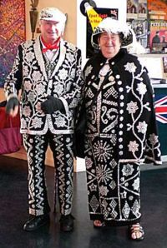 | A Pearly King (feminine form Pearly Queen) is a person dressed in a traditional cockney costume covered in mother-of-pearl buttons. These costumes were treasured heirlooms, hand made and sometime representing much of a families material worth.  The patterns used on pearly coats, which sometimes run in families, have special meanings, among them: Horseshoe = Luck, Doves = Peace, Heart = Charity, Anchor = Hope, Cross = Faith, Wheel = Circle of Life and Symbols of Playing Cards = Life is a gamble

Pearly Kings and Queens filler

You will need a copy for each group. Cut out the boxes, give each group a set and ask them to match the symbol with the meaning

Symbol - Horseshoe | Luck
Symbol - Doves | Peace
Symbols - Heart | Charity
Symbol - Anchor | Hope
Symbol - Cross | Faith
Symbol - Wheel | Circle of Life
Symbols - Playing Cards | Life is a gamble

Appendix A Slang
English | Slang | Usage
Arm | Chalk Farm | He broke his chalk.
Back | Union Jack | My old Union Jack's giving me gyp something chronic
Believe | Adam and Eve | I don't Adam and Eve it
Boat | Nanny Goat | I took my nanny out on the river.
Chat | Bowler Hat | Let’s get together for a bowler
Chest | Pants and Vest | This cough is killing me pants and vest
Chin | Biscuit Tin | He's got a big biscuit
Clock | Dickory Dock | What's the time on the dickory?
Cook | Babbling Brook | My missus couldn't babble to save her life.
Cupboard | Mother Hubbard | There's nothing in the mother.
Dead | Brown Bread | I'm telling you, mate. He's brown bread
Deaf | Mutt and Jeff | Poor buggers mutt and jeff.
Eyes | Mince Pies | She got beatiful minces.
Face | Boat Race | Nice legs, shame about the boat.
Facts | Brass Tacks | 'Ere, you've got your brass wrong!
Feet | Plates of Meat | Get your plates of the table.
Gloves | Turtle Dove's | Where's me turtle dove's
Good | Robin Hood | That sounds like it's robin
Gravy | Army and Navy | Can I have some army for my mashed?
Hair | Barnet Fair | She must be going out - she's got her Barnet done.
Head | Loaf of Bread | Don't just stand there - use your loaf.
Heart | Strawberry Tart | Me strawberry belongs to you
Hill | Jack and Jill | The store is up the jack.
House | Cat and Mouse | Went 'round to his cat to wake him up.
Kettle | Hansel & Gretel | I put the Hansel on for a nice cup of Rosy
Keys | Knobbly Knees | Have you got your knobblies with you?
Knees | Biscuits and Cheese | I've been on my biscuits all day.
Lies | Pork Pies | Blimey - he gets two beers in him and he starts telling porkies.
Lodger | Artful Dodger | She's taken in an artful to help pay the way.
Look | Butcher's Hook | Here - take a butcher's at this.
Mate | China Plate | How are you, my old china?
Mouth | North and South | I gave him a punch up the north.
News | Wooden Pews | Did you catch the wooden pews yesterday
Nose | Irish Rose | She gave me a kiss on my Irish.
Park | Noah's Ark | I'm taking my misses to the Noah.
Phone | Dog and Bone | She's always on the dog.
Pillow | Weeping Willow | 'ere. Get yer head off my weeping willow
Pinch (steal) | Half Inch | Someone's half-inched me pint!
Pocket | Lucy Locket | Keep it in your Lucy.
Shabby | Westminster Abbey | He's turned out a bit westminster today
Sick | Moby Dick | I'm feeling a bit Moby today.
Sister | Skin and Blister | She may be his blister but she's nothing like him.
Sleep | Bo-Peep | What I need is a good bo-peep.
Smell | Aunt Nell | He don't half Aunt Nell
Socks | Almond Rocks | Wouldn't it be nice if your almonds matched?
Son | Currant Bun | He's awfully proud of his currant.
Song | Ding Dong | Everyone gather round the piano for a ding dong.
Stairs | Apples and Pears | Get yourself up the apples and pears.
Stink | Pen and Ink | That's a bit of a pen and ink.
Story | Jackanory | Ye late! What’s the jackanory then?
Stranger | Queen’s Park Ranger | Who’s that Queen’s Park Ranger standing over there?
Street | Field of Wheat | He out standing in the field, waiting for a bus.
Sun | Current Bun | Old current bun's out today
Supper | Tommy Tucker | You can sing for your Tommy.
Table | Cain and Abel | Sit yourself at the cain and I'll bring you your Tommy Tucker –( supper).
Tea | Rosy Lee | I've just put the rosy on.
Thief | Tea Leaf | He's always been a bit of a tea leaf.
Throat | Billy Goat | I've got a sore billy goat
Till (Cash register) | Jack & Jill | 'E got nicked with 'is 'ands in the old jack and jill
Time | Lemon & Lime | Oi mate - what's the lemon & lime
Towel | Baden Powell | 'ere, wrap a baden powell around you. Nobody wants to see that!
Walk | Ball of Chalk | After a heavy meal I like quick ball round the square.
Wife | Trouble and Strife | I'm taking my trouble dancing tonight.

Girlguiding Essex West

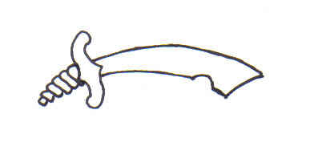

This is to certify that

__________________________

Took part in
a traditional trip around
the British Isles

on ______________

Badge Order Form

Once your unit has completed the British Traditions Challenge, return this form to order your badges.

Unit: ……………………………………………………………………

County: ……………………………………………………………………

Leader’s Name: ……………………………………………………………………

Address: ……………………………………………………………………

Postcode: ……………………………………………………………………

Phone or Email (in case of queries): …………………………………………………….

Number of Badges @ £1.00 each: …………………..

Add on the Postage (Badges will be sent second class)
1 – 20 Badges 67p
21 – 60 Badges 94p
60+ Badges £2.57

Amount Enclosed £ ………………………………..

Please make cheques payable to ‘Guide Association, Essex West’

Return to:
British Traditions Challenge Badge
Girlguiding Essex West
Suite S1, Business Centre
Church Road
Harold Wood
Romford
RM3 0JF

