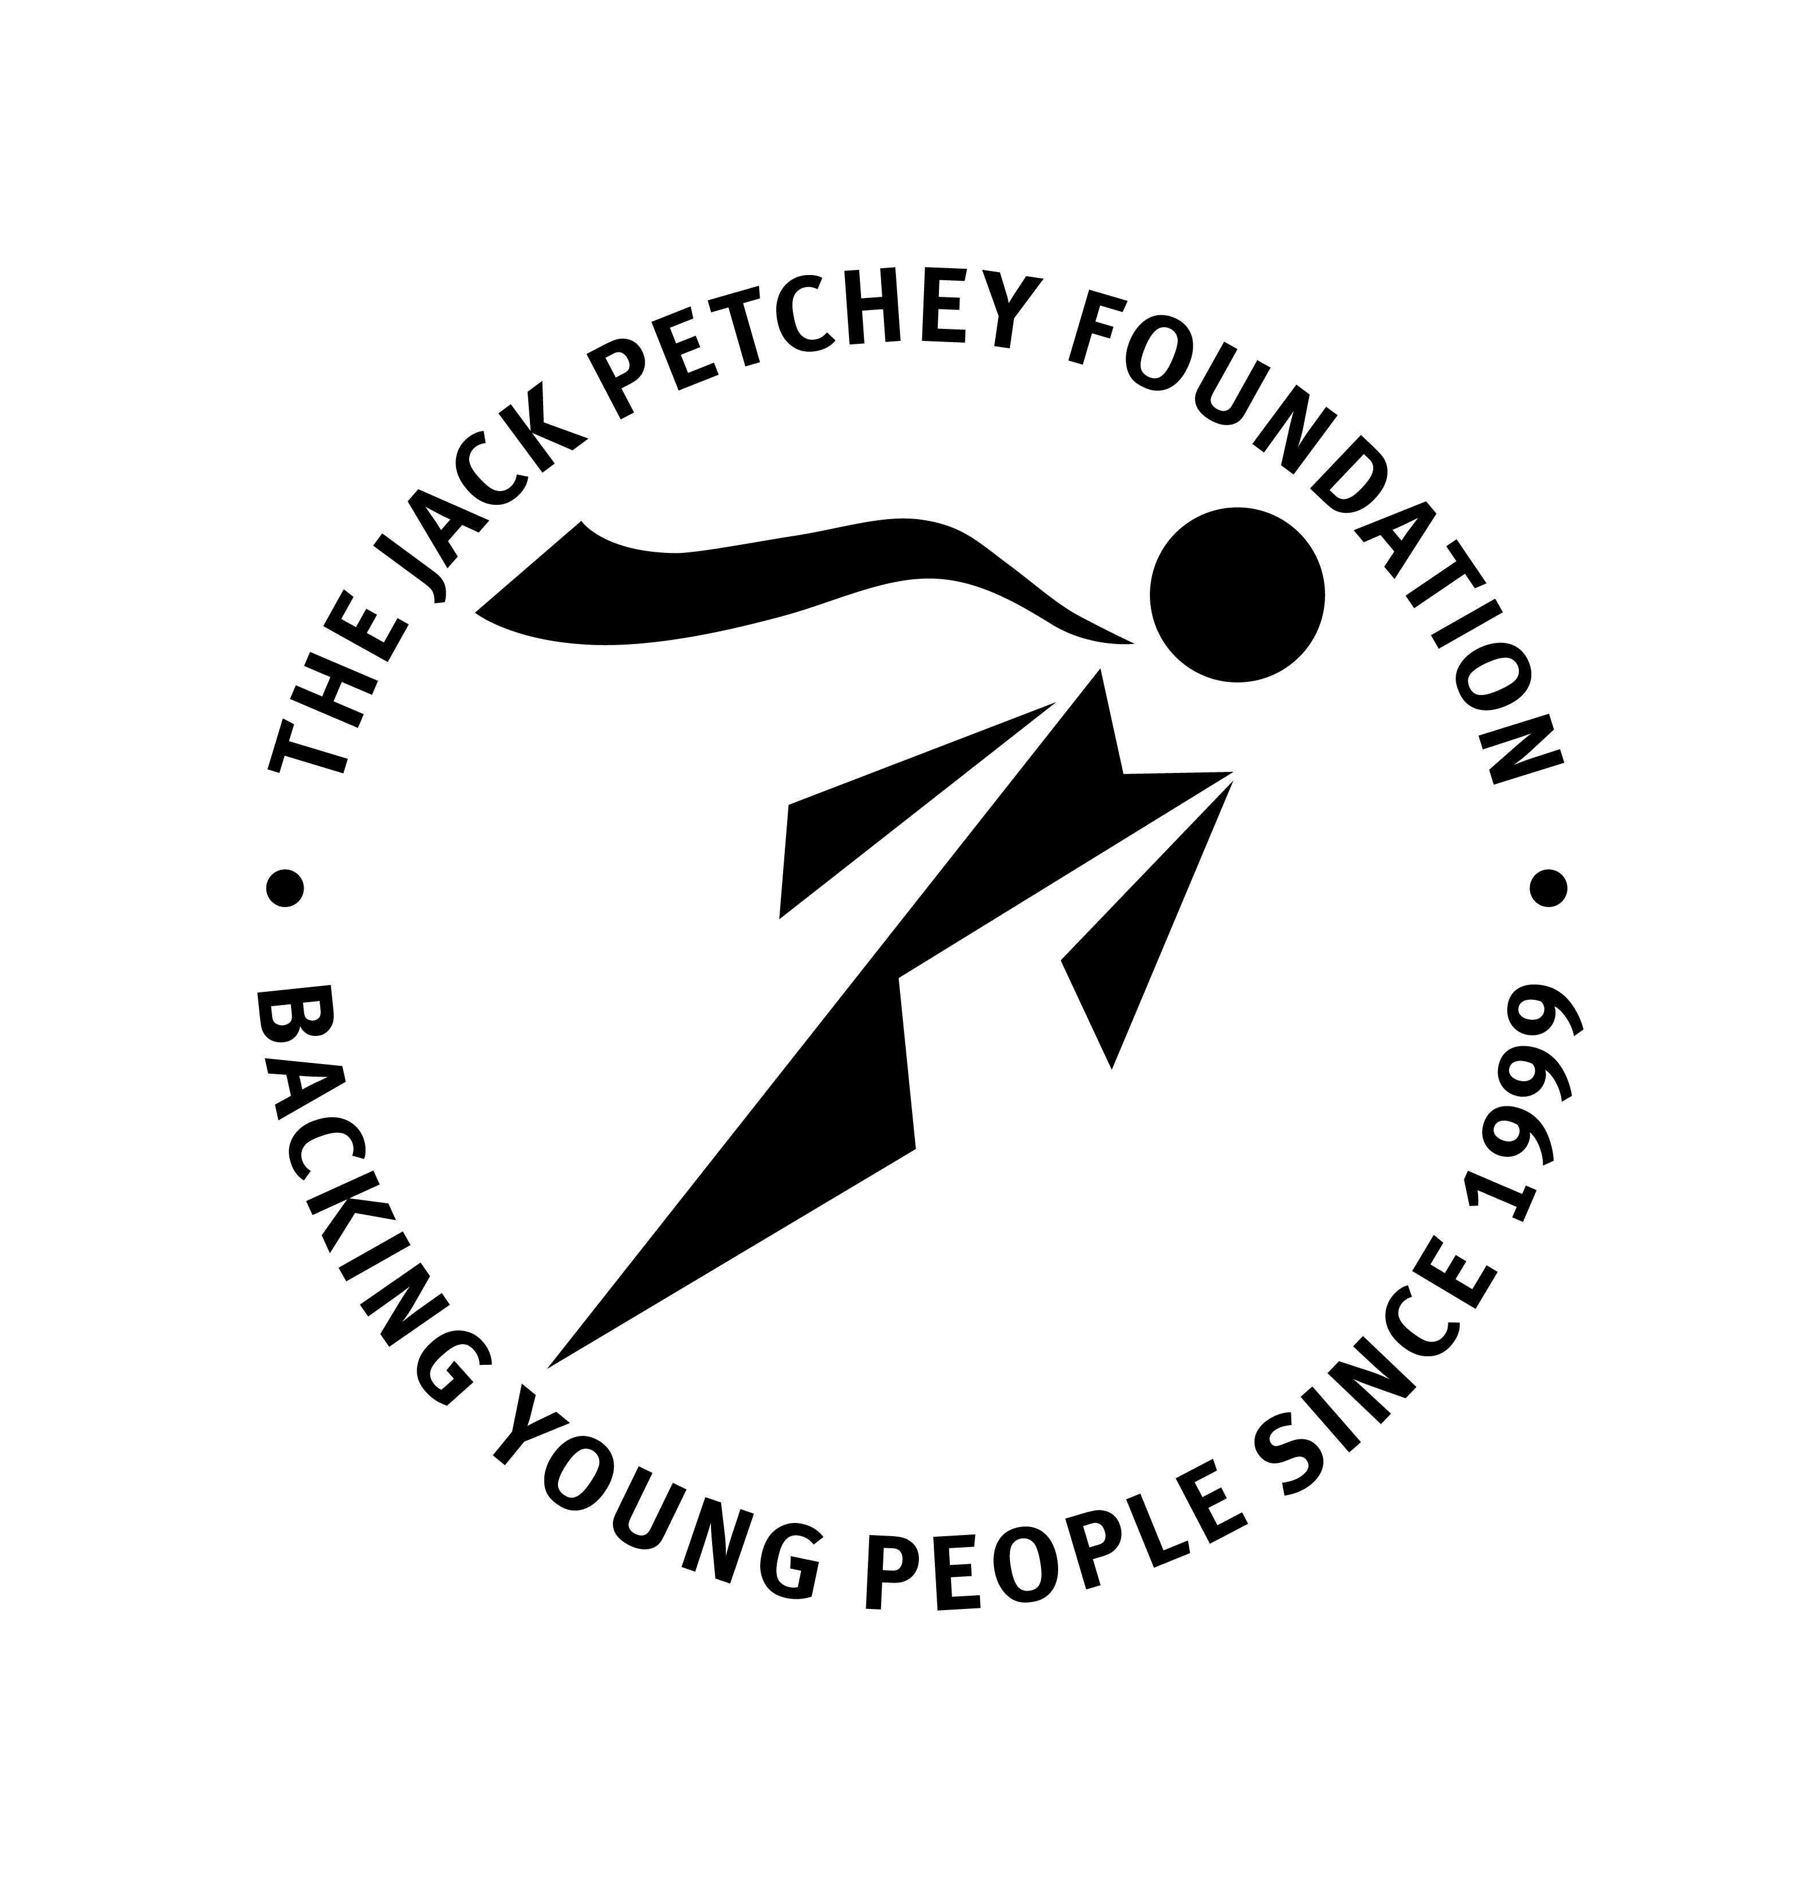
2025
Jack Petchey Foundation
Leader Award Application Form

The Leader Award is linked to the Achievement Award Scheme which must have been successfully operated within your organisation for at least 6 months – we do not automatically acknowledge receipt of your application but we will notify you of the outcome within six weeks

Details of your Organisation
Organisation Name:
Borough / District:

Recipient – The person who will receive the award
Name: |  | Position:
Address:
Postcode: |  | Email:
Length of Time with this Org (Must be over 2 years): |  |  | Age (Must be over 21):
Tel. Number
Please note:
We will be contacting the above named recipient in order to gain their permission to add them to our Award Winner database to receive further communication from us

Applicant - Your details (You must not be a relative of the nominee)
Name: |  | Position:
Address:
Postcode: |  | Email:
Tel. Number: |  | Mobile No:
Signature: |  | Date:
Details of the person supporting the nomination (they must not be a relative of the nominee)
The nomination must be supported by a second person, preferably from outside of the organisation e.g. parent, school governor, church minister
Name: |  | Position:
Tel. Number: |  | Email:
Signature: |  | Date:
Now please go to Page 2 and complete the Citation

The Leader Award Citation:

Please tell us why this person deserves this special award:

