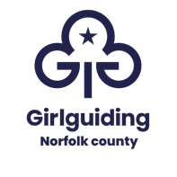
Girlguiding Norfolk & Girlguiding Suffolk
Banham zoo take over day

10:00 – 15:00 Sunday 12 October 2025

Main contact:

Unit name(s):

District and Division:

Email for confirmation:

Numbers attending:

Rainbows |  | Young leaders
Brownies |  | Leaders (unpaid)
Guides |  | Leader’s children (under4y)
Rangers |  | Additional adults (paid)

Payments
Cheque made payable to Norfolk Guide Association
enclosed for £
Please forward with the form to;
Banham event, Patteson lodge activity centre, 14 Great Hautbois Road, Coltishall, Norwich, NR12 7JN

OR

BACS payment made for £
BACS details: Barclays bank, Norfolk Guide Association,
Sort code: 20-62-53, account number 90680478
Payment made on:
Please use unit name as reference and forward this booking form via email to;
banham@girlguidingnorfolk.org.uk

Once booking is received, we will confirm receipt via email.
Coach subsidies will be forwarded via division and districts.

